# HTML-Basics-Lab

*In today's exercise, we will build a very simple page, in which we will practice everything from the lesson learned about HTML lecture. We will build it step by step following the instructions below.*

**Heading Stage**

First we need to create **three div** elements, each containing initially one heading.  
Headings need to be: **List exercise, Table exercise and Forms exercise**. (h1)

### Examples



**Paragraph Stage**

Next step is to create our paragraphs. They will hold the information about these three headings.

Under each heading add information about the current heading by putting it in the **paragraph.** You can copy/paste the information about every heading from the presentation.

**Also you need to place keywords (List, Table, Form) in span elements!**

If you stick to the presentation information. Expected output should be like this one below:

### Examples

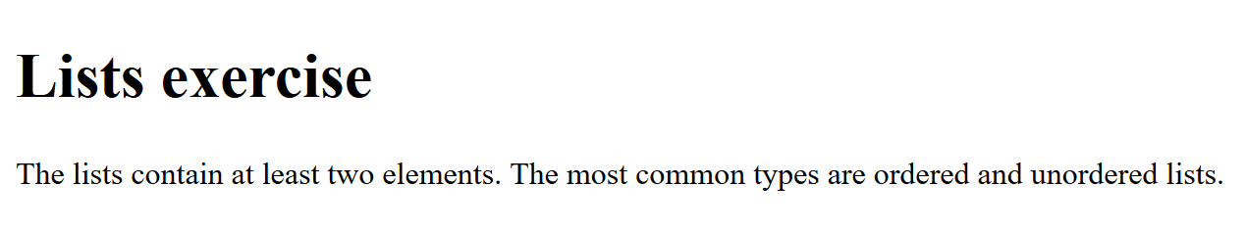

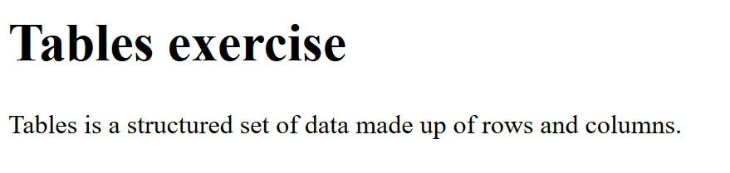

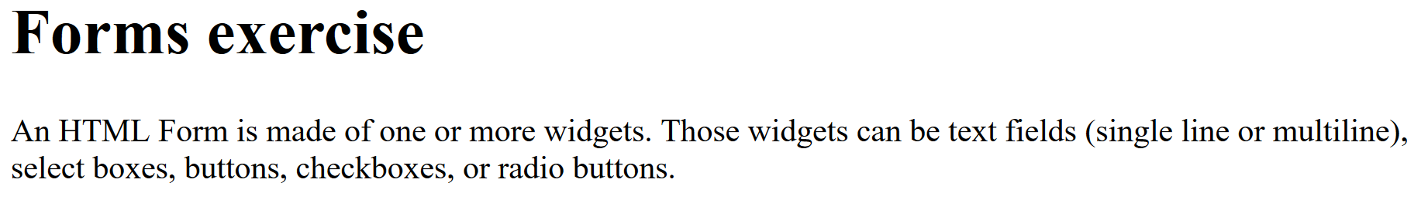

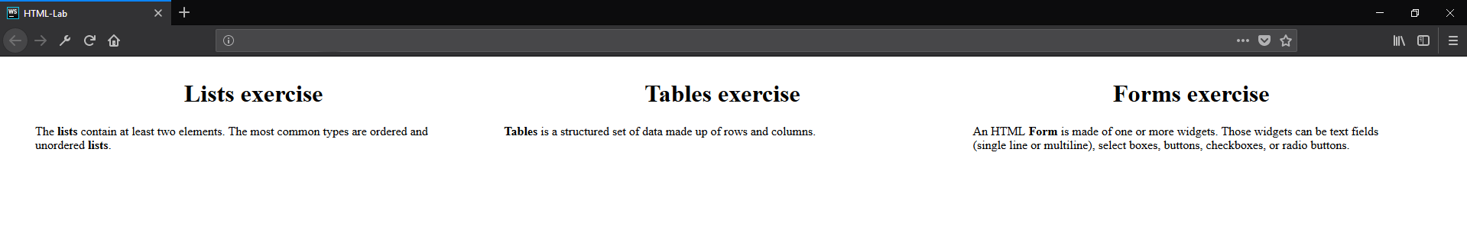

**List/Table/Form Stage**

Now it’s time to include **lists,** **table** and **form** to our HTML. After each paragraph in each **div** element create one (h2) Heading with text ‘Example’. Then we will make one example by following the (h1) Heading:   
**List** **example** need to be ordered (ol) with at least 3 elements. Like each of these elements, must have a unordered list (ul) nested to in with at least 2 elements containing information about the current order list item.  
**Table example** need to have 3 columns (Programming Language, Developed by, First appeared):   
List at least two languages by filling out the table.

**Form example** needs to have: Username, password, email and age fields + submit button:

### Examples

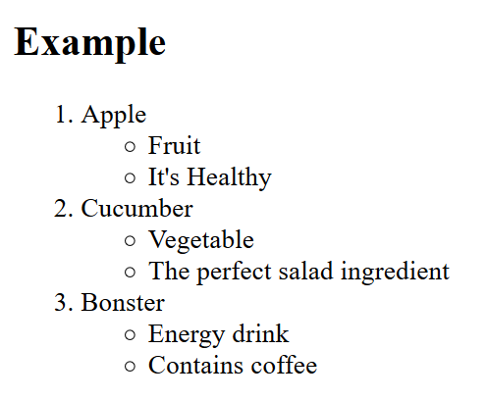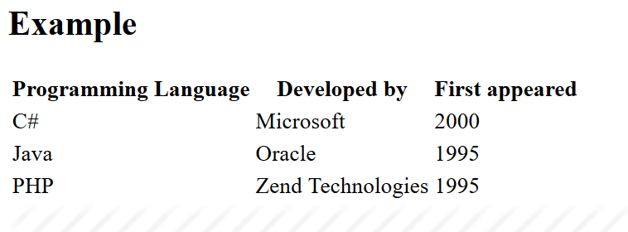

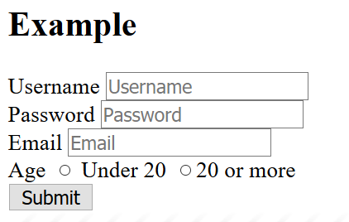

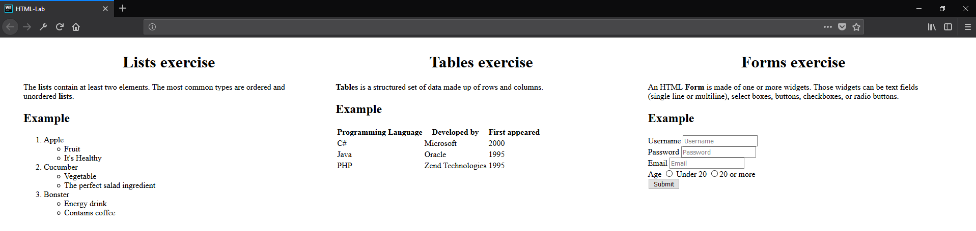

**Image Stage**

Try to find appropriate **icon(**picture**)** for every one heading and insert it **after the examples.**  
See the example below:

### Examples

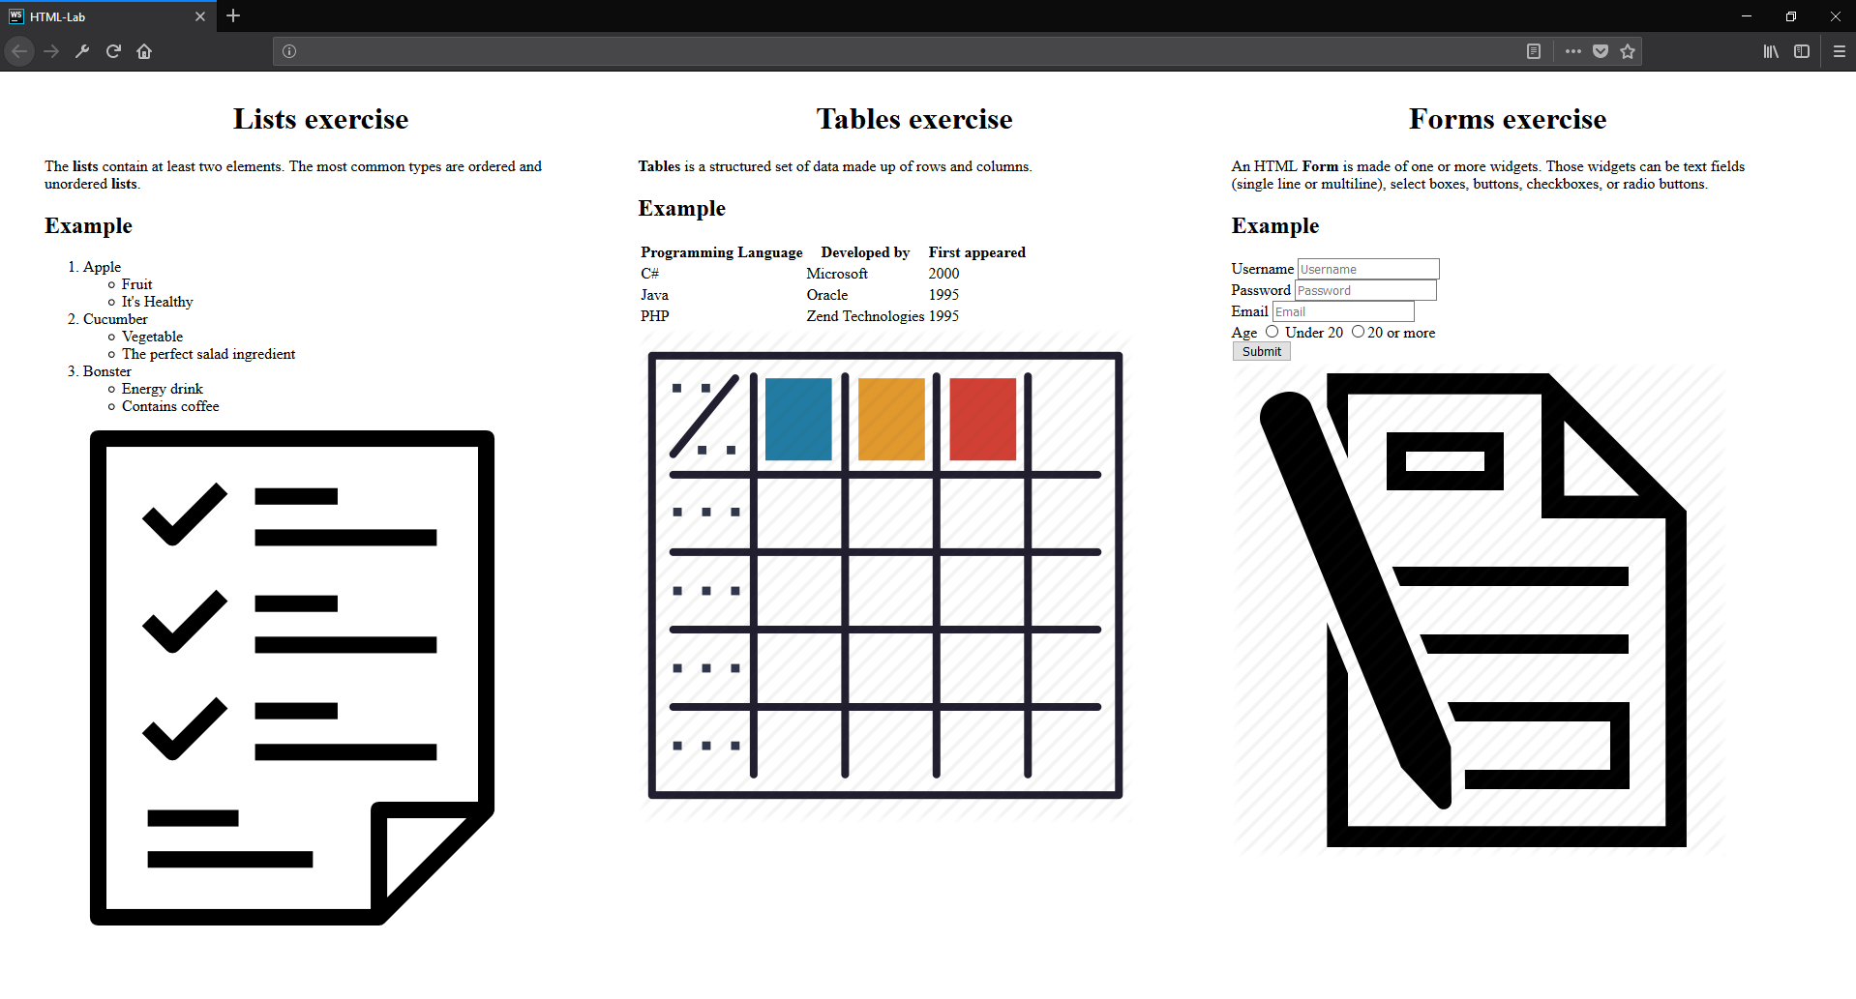

**Hyperlink Stage**

Our last stage is to include **hyperlinks**. You have to create a **new paragraph** after the img tagwith text:   
List/Table or Form icon link {HERE}. ‘HERE’ should be a **link** to the photo we added before that.  
Тhe final result should be something similar to the photo shown below:.

### Examples

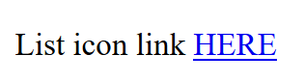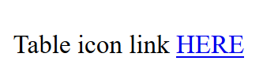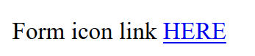

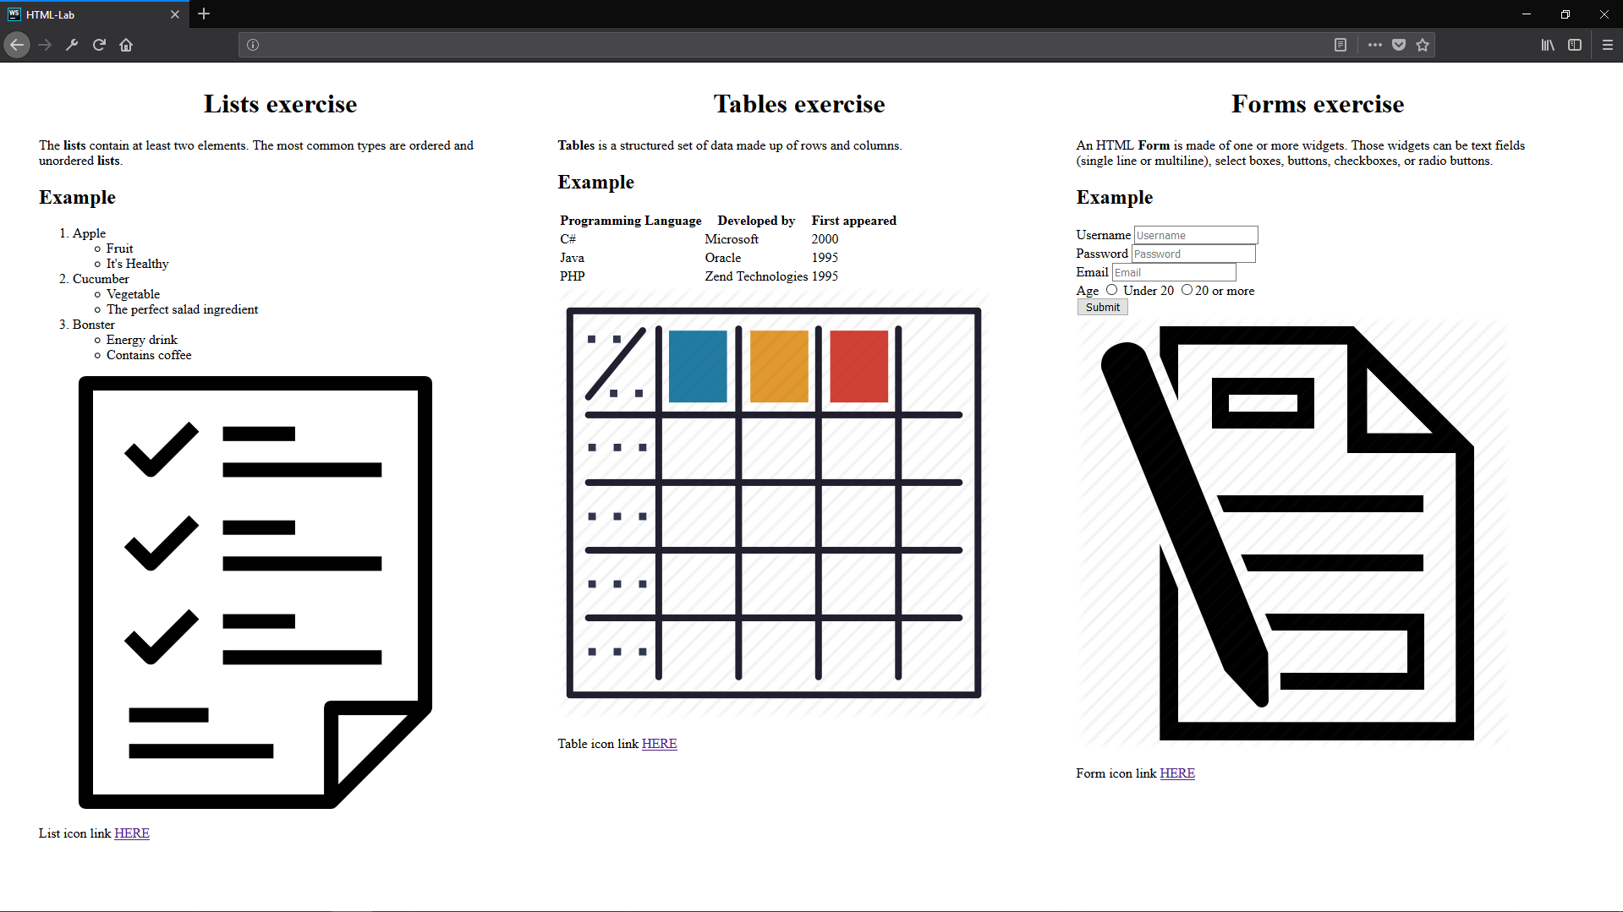

*And we are done! ☺*